April Week of 6th-10th | 2020

Gonzalez Elementary IN HOME Physical Education
American Heart Association
Click each day on KHC Link of the Day
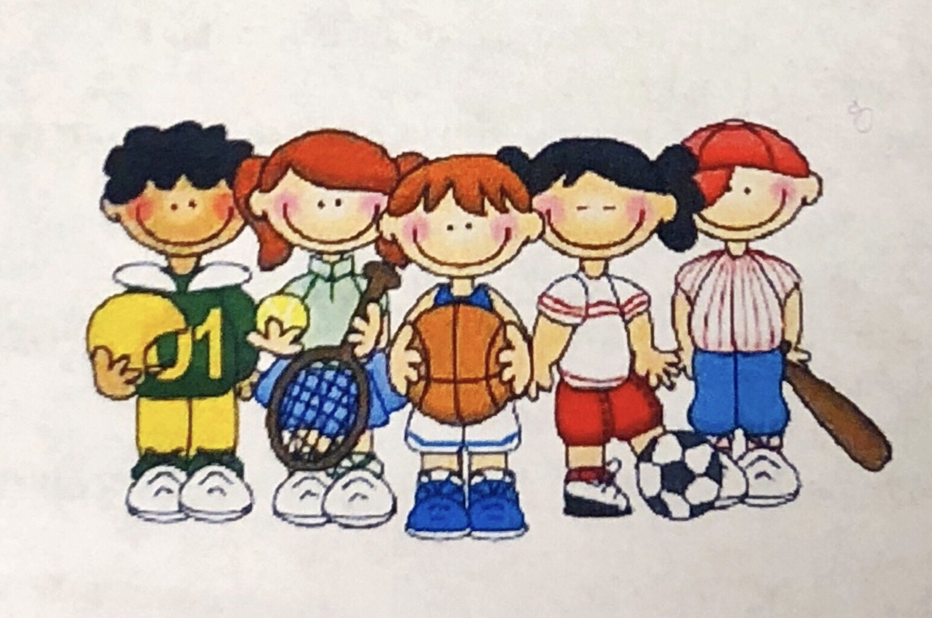
Monday KHC: Just Dance
Tuesday KHC: Know Your Heart
Wednesday KHC: FINN’S Missions
Thursday KHC: Jump Around
Friday KHC: Connect the Dots
How can I make sure I stay healthy and active while at Home?
Ways to take care of our bodies:
Remember to drink water daily. Eat fruits or vegetables with every meal. Move around often.
Wash your hands often for 20 seconds. Cover your cough and sneeze with your shirt. Get 8 hours (or more) of sleep.
Each day you can choose your workout! Pick ONE of the daily exercises and click on KFC Link. You can also choose an exercise to do from the daily choice list on the left. Post pictures on ClassDOJO HAVE FUN and STAY ACTIVE!
Monday 6 | Tuesday 7 | Wednesday 8 | Thursday 9 | Friday 10
Run 5 Laps or around your house or 10 your back yard  AND/ OR  Stand and read for 20 minutes | BATMAN Workout www.tinyurl.com/ BatWorkout  AND/ OR  BATGIRL Workout www.tinyurl.com/ BatgirlWorkout | Find 3 songs you like and Dance them  AND/ OR  Stretch for 5 Minutes, 10 jumping jacks, squads, toe touches | ANTMAN Workout www.tinyurl.com/ AntmanWorkout  AND/ OR  CYBORG Workout www.tinyurl.com/ CyborgWorkout | Kick a ball  against a fence or wall 30 times  AND/ OR  Shoot some  Hoops into a  trash can with  a ball or sock  for 30 times
DAILY CHOICES
-Create an indoor obstacle course
-Build a cup tower and bowl it over with a ball or stuff animal
-Run or walk for 5 minutes in your back yard.
-Create a dance and share it with someone else in your house
-Throw and catch a ball or stuff animal with someone or by yourself
-Play outside for at least 15 minutes
. STAY HOME STAY FIT STAY SAFE .

